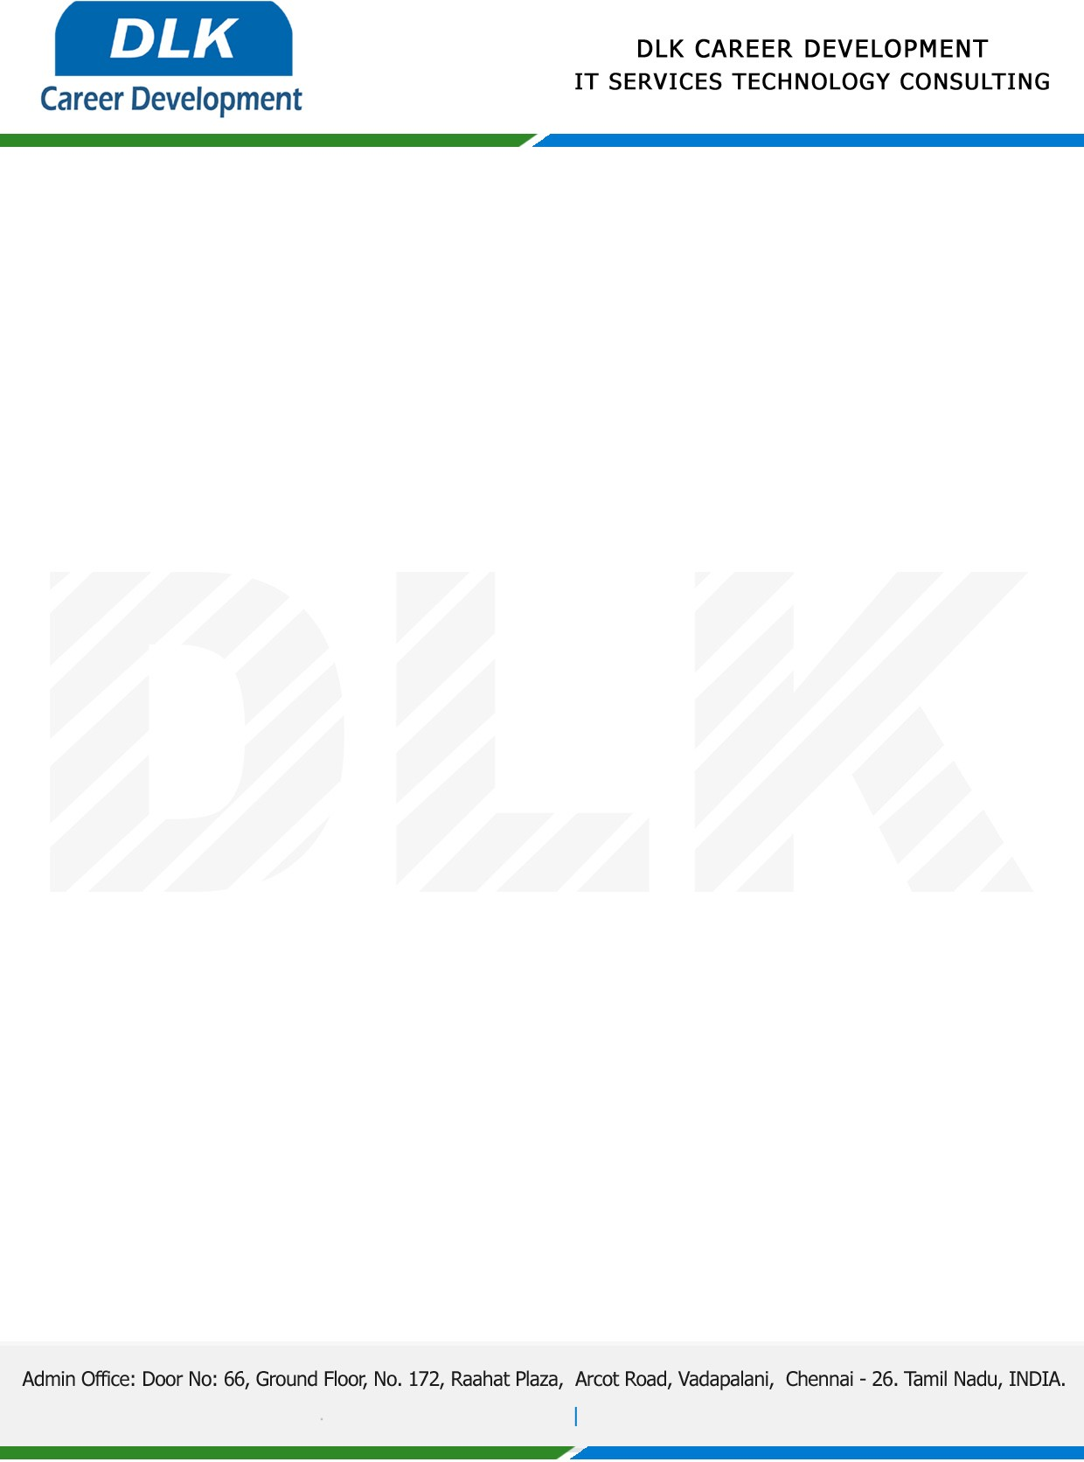

**Date: 05/ April /2023**

**SUB: PROJECT COMPLETION CERTIFICATE**

This is to certify that **MR** **ADHAVAN S (REG NO:** **214012101007) MCA-Computer Application,** final year student **Dr MGR University, Chennai** has Successfully Completed the Project Work under the domain of “**Java”** in our organization during the Period **(December 2023** to **March 2023).**

**Topic:** Secure Authorized Keyword Search with Customizable Information and Dual Server Cryptography for the Owner.

We appreciate your interest in **DLK CAREER DEVELOPMENT**

**“Best Wishes for Your Future Endeavors “**

